Software Requirements Specification

for

Automated IFC Asset Detection System
Version 1.0
Prepared by Gavin Woodruff, Prashant Kandel, Jonah Deschenes
St. Cloud State University
10/01/2025

Table of Contents
Table of Contents ii
Revision History ii
1. Introduction 1
1.1 Purpose 1
1.2 Document Conventions 1
1.3 Intended Audience and Reading Suggestions 1
1.4 Project Scope 1
1.5 References 1
2. Overall Description 2
2.1 Product Perspective 2
2.2 Product Features 2
2.3 User Classes and Characteristics 2
2.4 Operating Environment 2
2.5 Design and Implementation Constraints 2
2.6 User Documentation 2
2.7 Assumptions and Dependencies 3
3. System Features 3
3.1 System Feature 1 3
3.2 System Feature 2 (and so on) 4
4. External Interface Requirements 4
4.1 User Interfaces 4
4.2 Hardware Interfaces 4
4.3 Software Interfaces 4
4.4 Communications Interfaces 4
5. Other Nonfunctional Requirements 5
5.1 Performance Requirements 5
5.2 Safety Requirements 5
5.3 Security Requirements 5
5.4 Software Quality Attributes 5
6. Other Requirements 5
Appendix A: Glossary 5
Appendix B: Analysis Models 6
Appendix C: Issues List 6

Revision History
Name | Date | Reason For Changes | Version

Introduction

Purpose
This Software Requirements Specification (SRS) defines the requirements for the Scope 360 IFC Asset Detection and Review Prototype. The software enables automated detection of IFC assets in indoor and outdoor 360 degree panoramas. It presents detections for human review through a React frontend, and (optionally) geolocates assets on a map.
This SRS covers the prototype version of the product with an emphasis on detection, review UI, and a feedback loop to improve machine learning accuracy.

Document Conventions
- Priorities are classified as High, Medium, or Low.

Intended Audience and Reading Suggestions
- Developers
- Project Managers
- Testers
- Stakeholders

Project Scope
The prototype aims to replace manual asset detection with automated detection from property panoramas. Benefits include faster asset documentation, lower operational costs, and higher accuracy across retail portfolios.
Core Objectives:
- Detect IFC assets in cubemap panorama images
- Provide a review UI for human confirmation, rejection, or updates
- Feed reviewer input back to an active learning loop to improve model performance.

References
- Project Scope Document: Scope — 360° IFC Asset Detection, Review, and Geolocation Prototype (Retail Digital Twin Platform, 2025-08-27)

Overall Description

Product Perspective
The prototype is a self-contained system that integrates computer vision, a React based review UI, and a database for storage. It is intended for a larger retail digital twin platform but isn’t a replacement for what is currently used.
Major Components
- Frontend: React UI with panorama viewer and detection overlays.
- Backend: API services to ingest, review, and export images.
- Machine Learning: A python pipeline running detection on images for assets.
- Database Storage: PostGIS is used to store images, detections, and metadata.

Product Features
- Automated detection of IFC assets in 360 degree cubemap images.
- Reviewer interface for panorama viewer with overlays, sortable detection table with functionality to confirm, reject, or update detections.
- Active learning loop using reviewer feedback to update training datasets.

User Classes and Characteristics
- Reviewers
- QA Leads
- Developers
- Managers/Stakeholders

Operating Environment
- Frontend: Modern browsers like Chrome, Firefox, Edge, etc.
- Backend: FastAPI in Docker containers.
- Database: PostGIS
- Machine Learning:

Design and Implementation Constraints
- The front end must use React
- The database must be PostgreSQL
- It uses Docker Containers to isolate different components of the software
- The budget for the project is $100
- The project timeline is 8 months

Requirements Standards
- IEEE Std 830-1998
- IEEE/EIA 12207.1-1997

User Documentation
- There is currently no plan to provide any written documentation with the software
- There may be a short training session/demonstration to familiarize the users with the system.

Assumptions and Dependencies
- It is assumed that the geographic data contained in the images is correct. If this assumption is incorrect, it will be nearly impossible to accurately place IFC assets on a map.
- The success of this project is dependent on having access to a large enough and complete database of panoramas that can be used to train the model.

Major Business Events
- A panorama is brought into the system for review
- An asset detection is made by the system
- A reviewer either accepts, declines, or edits the detection to help train the model
- A labeled panorama is stored in a database for later use

Business Use-Case Scenarios
- Need to be able to view a panorama.
- Need a way to automatically detect IFC assets in panoramas.
- Need a way to store panoramas with labeled IFC assets.
- Need a way to view labeled panoramas.

Product Use-Case Scenarios
- The system can display for the user a panorama.
- The system will detect IFC assets in panoramas.
- The system will seek input from users to help improve its prediction model.
- The system will store panoramas that have been labeled.
- The system will allow the user to search the database and view labeled panoramas.

System Features
The main features of the system are as follows.

Panorama Ingestion
3.1.1 Description and Priority
For the system to be able to make asset detections it needs panoramas to make the detections on. This feature will allow users to input panoramas for asset detection.
3.1.2 Stimulus/Response Sequences
The user will open the system. They will navigate to the screen where they can input panoramas. After they select the button to input panoramas, they must select 6 images to be input into the system. When they have finished that the system will take the images and store them as a panorama.
3.1.3 Functional Requirements
    - The system must allow the user to input a panorama for analysis.

Asset Detection
3.2.1 Description and Priority
This is the main feature of the system. The system will take a panorama that was previously loaded into the system. Then, using machine learning, it will make automatic IFC asset detections. The system will then display them to the user and store them in the database.
3.2.2 Stimulus/Response Sequences
The use will open the system. They will navigate to the screen where they can request asset detections. They will select the panorama for which they want to detect assets. Then they will select a button to start the system making detections. After the system displays the detections to the user, the user is able to accept the asset detection and tell the system that it was a correct detection. In addition to that, the user can also notify the system that the detection was incorrect and correct the system.
3.2.3 Functional Requirements
    - The system must detect IFC assets in cube map panoramas.
    - The system must accept feedback from the user on asset detections.

External Interface Requirements

User Interfaces
The user interface will be implemented as a React-based web application. The interface will provide intuitive views and panels for reviewers, developers, and QA leads to interact with the system. Main screens include a Review screen and a Image Upload screen. The panorama screen includes a 3D viewport that displays the cubemap of panoramas, and if detections are made, it will display detections visually too. The Review screen will also allow the user to reject or edit detections made in the 3D viewport. The Image Upload screen will display input fields for the 6 images that make up the cubemap as well as metadata related to those images such as latitude and longitude. Interface guidelines include a consistent placement of primary actions like confirm or reject buttons.

Hardware Interfaces
There are no hard requirements for the hardware for this system. It is only required that the computer running the system be able to run a PostgreSQL database and a web browser.

Software Interfaces
The system will interface with a PostgreSQL database. The database will be responsible for storing the data necessary for making, storing and displaying asset detections. There will be tables for panoramas, IFC assets, asset detections, buildings where panoramas were taken, and user reviews of the asset detections.

Communications Interfaces
The system communicates over HTTPS using RESTful APIs. All inter-service communication is handled within Docker Compose. Key interfaces include Frontend and Backend, Backend and Database, Backend and Machine Learning. The database makes use of PostGIS SQL to save data for the system. Standards include communication via secure HTTP and Internal Docker networking using isolated bridge mode.

Other Nonfunctional Requirements

Performance Requirements
- The system must be able to make a detection in less than 5 seconds

Safety Requirements
- The system must be tested and vetted to ensure that it reaches an accuracy level of 99%. This will ensure that there are no negative consequences from incorrect detections.

Security Requirements
- The system must keep all customer images secure.

Software Quality Attributes
- Usability: The interfaces should be intuitive and require minimal training.
- Reliability: The system should recover from failed detections or upload interruptions through retry mechanisms and status reports.
- Maintainability: Code should follow modular architecture using React components and REST endpoints.
- Portability: The entire prototype should be runnable through Docker on any machine with Docker installed.
- Extensibility: The ML service and database schema should allow adding new IFC classes or detection categories without major refactoring.
- Performance: Average detection time per panorama must remain under 5 seconds for a single cubemap. Frontend operations must remain responsive under 200ms per UI action.

Other Requirements
- Database requirements: The database must use PostgreSQL with PostGIS for spatial support. Geometry columns store asset points, lines, and polygons in SRID 4326.
- Internationalization: English will be the primary and only supported language in the prototype.
- Legal & Ethical Requirements: No personally identifiable information will be stored or processed. Image data must comply with local privacy regulations.
- Reuse Objectives: The system architecture should be reusable for other visual asset detection tasks under different classes.
- Data Residency: All data must remain in U.S. based servers when deployed to AWS
Appendix A: Glossary
Term | Definition
IFC | A standardized data model for building and construction elements.
Panorama | A 360 degree image captured by a camera and split into six cubemap faces.
Cubemap | A 3D representation of a panoramic image using six square faces
Detection | The automated identification of an asset by the ML system
Reviewer | A user who verifies system detections for accuracy
Active Learning | A training strategy where the system retrains on corrected labels from user feedback.
PostGIS | A spatial database extension for PostgreSQL
Confidence Score | A numerical measure of how certain the model is about a detection.

Appendix B: Analysis Models
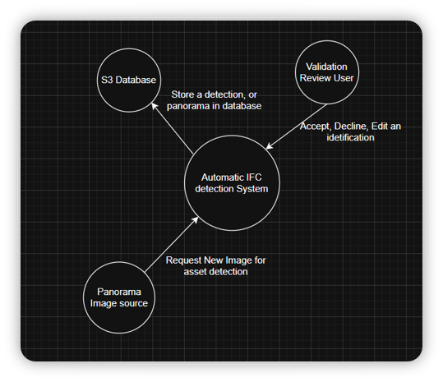
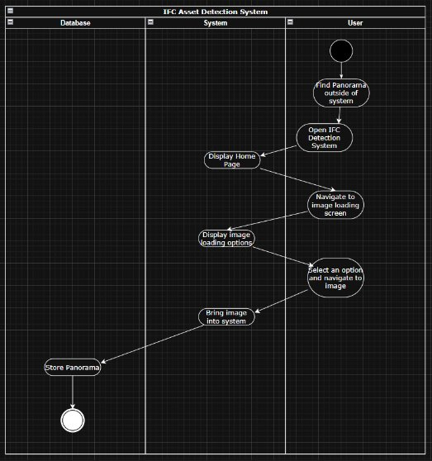
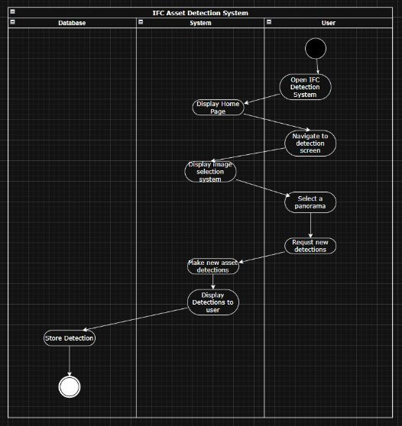

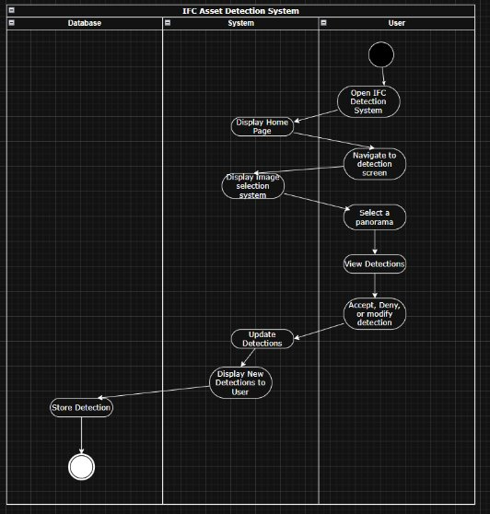
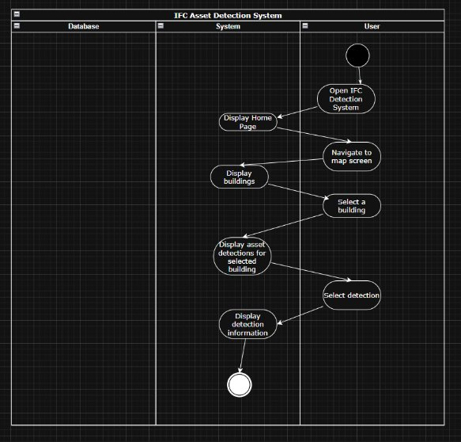
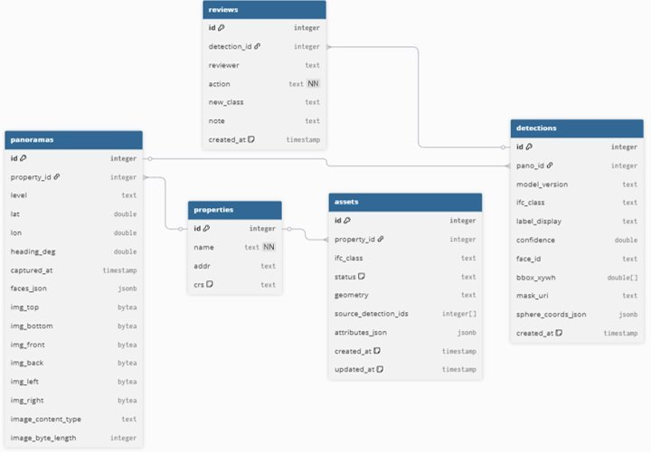
Appendix C: Issues List
Issue ID | Description | Status | Owner
ISS-001 | Define final IFC class list for V1 | Resolved | Team
ISS-002 | Select final model between YOLOv8 and GroundingDINO for fine-tuning | Resolved | ML
ISS-005 | Automate retraining loop after QA approval | Pending | ML

